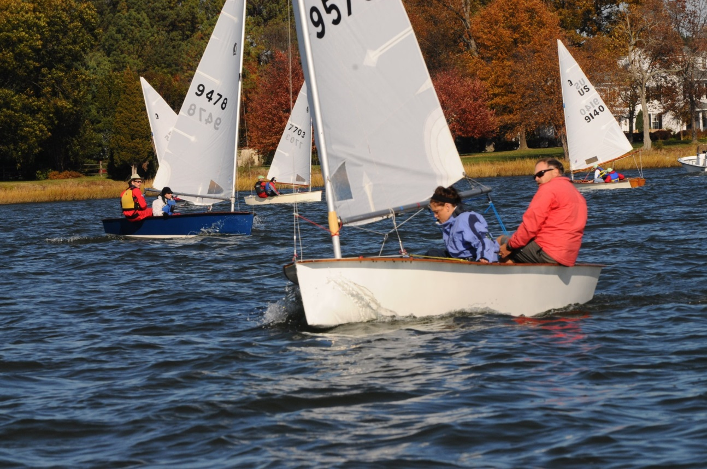
Penguin for Sale 9576
Burtis self bailing with Burtis centerboard and rudder.
Multiple regatta wins. Comes with 2 North Sails, trailer and dolly.
$3200. Ready to sail.
Call or email Jonathan Bartlett 410-353-6418
Jonathan.Bartlett@northsails.com

